Introduction

The power part of the system is based around a relay and a fuse. Relay shall be PCB mounted. Fuse shall be in a holder. The fuse holder shall be PCB mounted.

Connector/Terminal selection
Connector shall be:
- spring loaded terminal.
- Rated to 15A.
- Accepts wires with diameter 0,5 to 2,5 mm².
- Survives 100 mating operations.

Degson DGPS2.5R-5.0-02P terminal block was selected. These are spring loaded, and they make installation easy. Samples in the office left a good impression and it satisfies all electrical requirements.

Relay selection
Relay type is 1 from C – meaning Single Pole Double Throw.

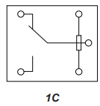
J1071CS5VDC.36 is chosen. Coil is supplied by 5V, but mounting options shall be provided to use 24V coils instead. Coil resistance is 69Ω ± 10%. Considering the minimum coil resistance 62,1Ω the maximum coil current is 80,5mA.

Circuit output will be connected to COM on the relay. There will be a mounting option for 0R resistor on both NC and NO contacts. NO is used by default. TLRZ2BTTD is used for the jumper. It’s in 1206 package, it can carry 50A continuous current and for 0,1s over 500A.

Switching circuit
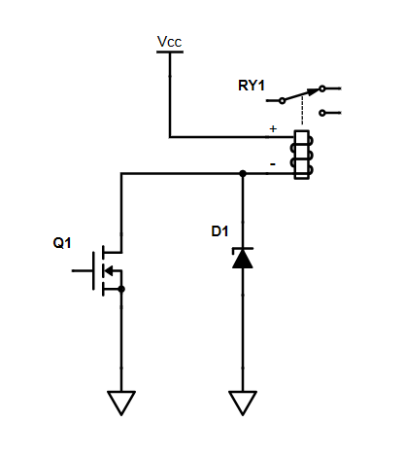
Components will be selected from Krakul library. This will save time.
BSS123 is selected. Continuous drain current is 0,17 A and Vds is 100V. It can be turned on by 3,3V and it’s in SOT-23 package.

Selected diode is SMF48A. It will limit the voltage on Q1 gate to safe levels (around 60V), but higher voltage forces the coil field to collapse sooner. This means that the relay contacts open faster.

Fuse holder and terminal block
Multicomp MCCQ-122 is selected for Mini-Blade fuse. It’s rated for up to 15A fuses.

Freewheeling diode
There may be different type of loads in the output including inductive loads. Even with purely resistive loads the cable lengths in the system are non-trivial. Thus, free wheeling diode is needed at the output the prevent excessive sparking and damage to relay at load disconnect.
SS24FL is chosen from Krakul component library. Maximum current expected trough this diode is at highest the rated current of the output. If the load pulls 15A at the time when relay is turned off the current will flow trough this diode for a short period.
SS24FL is rated for 50A Non-Repetitive Surge current.

Final circuit

This figure does not show the output voltage measurement circuit. It is shown in a separate design description.
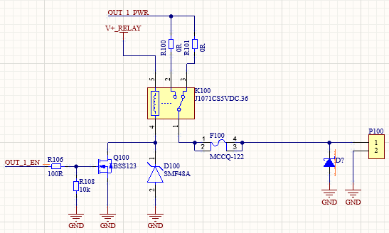
Figure 1: Power output circuit

100Ω resistor limits the inrush current to Q100 gate and reduces noise generated. 10kΩ resistor pulls Q100 gate low when it’s not actively driven high by the MCU. This prevents the transistor from opening due to floating gate.

